During autumn 2013 the Office of Economic and Workforce Development’s Invest in Neighborhood initiative conducted a survey along the Middle Polk corridor. 140 surveys were collected from residents, employees, business owners, shoppers, and other key stakeholders in the community. Below are some of the key findings.

What do you like most about Middle Polk?
Survey participants identified several important, positive characteristics of the corridor – including the local businesses and vibrant street life.
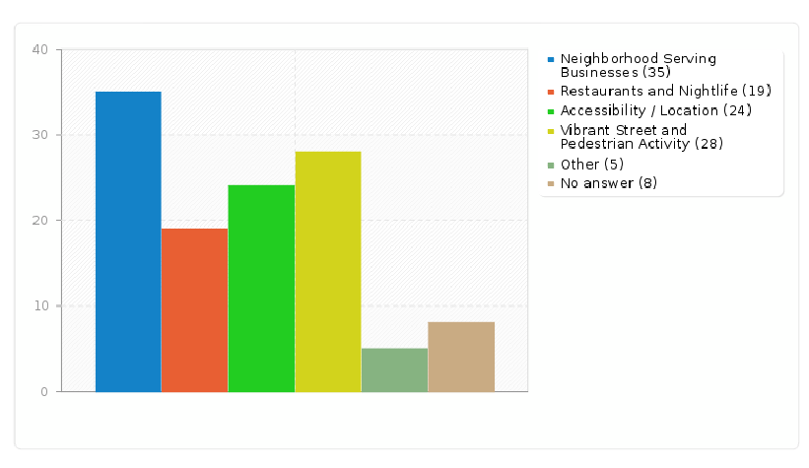

What are the biggest challenges affecting Middle Polk?
Unsafe environment for pedestrians and cyclists was the most critical challenge identified by survey participants.
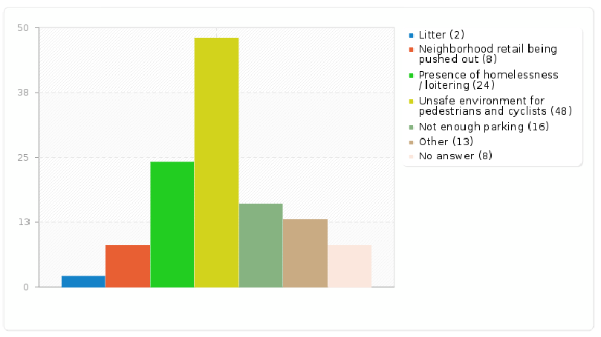
Demand for New Business
Demand was identified in two survey questions for a grocery store, a hardware store, affordable restaurants, and other shopping (such as books and music stores). The majority of respondents also indicated that they would patronize these kinds of new businesses on Middle Polk daily, several times per week, or weekly.

What types of small businesses have you left Middle Polk to patronize during the past week? 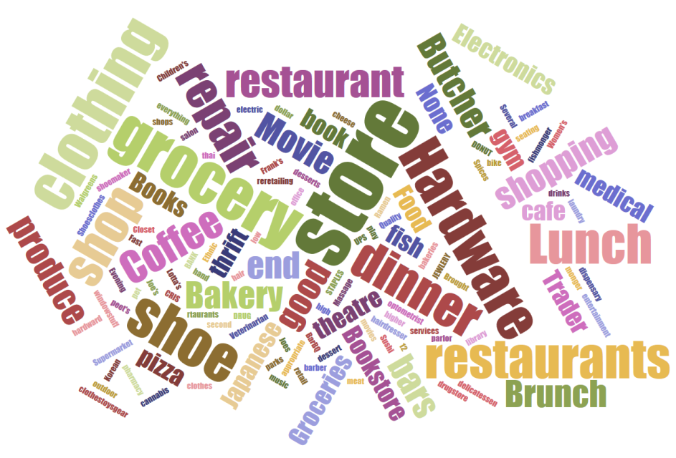

What type of business would you most like to see more of in Middle Polk?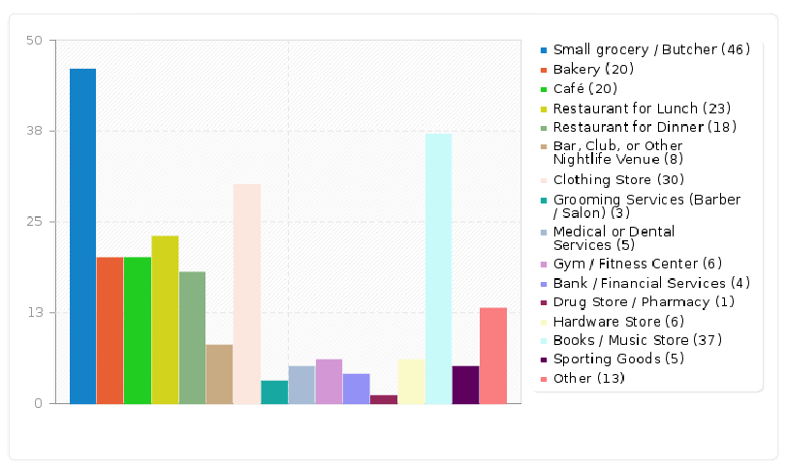
What would you like the City, the Middle Polk Neighborhood Association, and other partners to prioritize in the corridor?
Business attraction and cleaning activities – both with storefronts and corridor wide – were deemed most important. Supporting existing businesses and addressing issues around parking and biking were also identified as important priorities for the area.

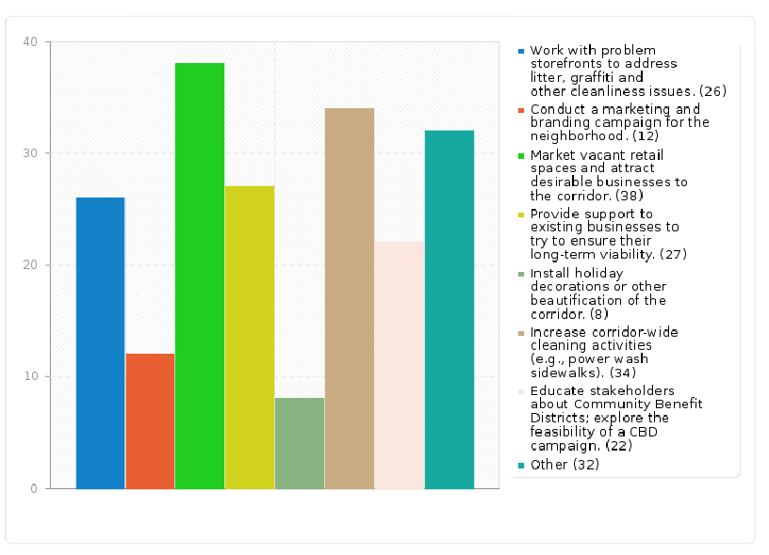

Next Steps
The results of the survey will be shared with the Middle Polk community to set future priorities and actions in the corridor. To learn more about the next steps, contact Jordan Klein at (415) 554-6645 or jordan.klein@sfgov.org. To learn more about the Invest in Neighborhoods initiative, visit: http://oewd.org/IIN.aspx.

