Date: October 21, 2016
District: 4 – Bay Area
Contact: Robert Haus
Phone: (510) 715-7212 Cell

SAN FRANCISCO-OAKLAND BAY BRIDGE BIKE PATH
OPENS TO YERBA BUENA ISLAND ON SUNDAY

Oakland – Caltrans has completed the final segment of the 4.5-mile San Francisco-Oakland Bay Bridge (East Span) Bicycle/Pedestrian Path connecting the current bike path from Emeryville with the new endpoint on Yerba Buena Island, and will open it for use around noon on Sunday, October 23.

In this Caltrans News Flash, we show what to expect when you ride across the bridge portion of the path, which is a 15.5-feet-wide, striped path with one bike lane in each direction and an outside lane for pedestrians.

This video can be viewed at: https://youtu.be/oIihzODbaOc

“Opening this bicycle pedestrian path to Yerba Buena Island marks an important milestone for making this a true, multi-modal transbay corridor,” says Caltrans District Director Bijan Sartipi. “This important milestone helps bring greater focus to the next phase of reaching San Francisco by cyclists and pedestrians.”

To access the path, vehicles may park at the Caltrans Bridge Yard Building at 210 Burma Road in Oakland. Currently, there is no parking near the landing on Yerba Buena Island, however the San Francisco County Transportation Authority will provide a free shuttle for cyclists and pedestrians every 30 minutes on the hour and half hour from the landing on Yerba Buena Island to parking on Treasure Island. Cyclists and pedestrians should use caution, as there are no sidewalks or dedicated bike lanes from the landing to Treasure Island due to ongoing construction on the island. Caltrans will continue construction on the slope at the end of the path on Yerba Buena Island with a tentative completion by summer 2017. Additional construction will follow by the San Francisco County Transportation Authority and Treasure Island Development Association for the next several years. Caltrans reminds motorists and cyclists to be mindful of each other and share the road. For Bay Bridge Bike Trail Shuttle information, visit http://sftreasureisland.org/bay-bridge-trail .

“Congratulations to Caltrans for completing this historic bicycle and pedestrian path to Yerba Buena Island that connects the East Bay to San Francisco for those traveling by bicycle or by foot,” said San Francisco Supervisor Jane Kim, whose district includes Yerba Buena and Treasure Islands. “This type of project takes a tremendous amount of inter-agency collaboration and community involvement, so I would also like to thank the San Francisco Bicycle Coalition, WalkSF and our County Transportation Authority (CTA), Treasure Island Development Authority (TIDA) and SF Municipal Transportation Agency (SFMTA) for working together to improve access to the Islands for everyone.”

The bike path will be open daily from 7:00 AM to 6:00 PM. Hours will be extended in the spring and summer, and the path will be periodically closed while demolition work continues on the old Bay Bridge. Bicyclists and pedestrians are advised to check www.baybridgeinfo.org before planning their trip to view the closure schedule and more information. Caltrans will also share closure information on the Bay Bridge’s Twitter account: @BayBridgeInfo. We appreciate the public’s patience as we continue this critical work to preserve the San Francisco Bay.

Caltrans has been working closely with its partners, including Metropolitan Transportation Commission, the California Highway Patrol, Treasure Island Development Association, and San Francisco County Transportation Authority to make a safe and accessible bridge bike path.

This News Flash is the 99th in a series of videos highlighting Caltrans’ activities that present the wide-ranging and critical work that Caltrans does to enhance California’s economy and livability. To see more of these and other videos, search for #CaltransNewsFlash on Twitter or go to http://bit.ly/1ez3LYz .

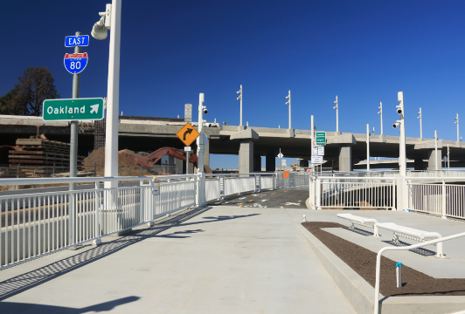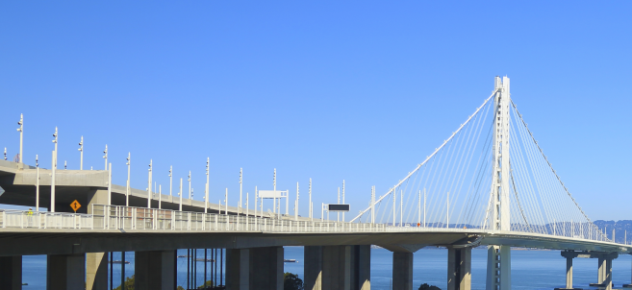

Photo Caption: Looking Eastward from the Alex Zuckermann Bike/Pedestrian Path on
Yerba Buena Island

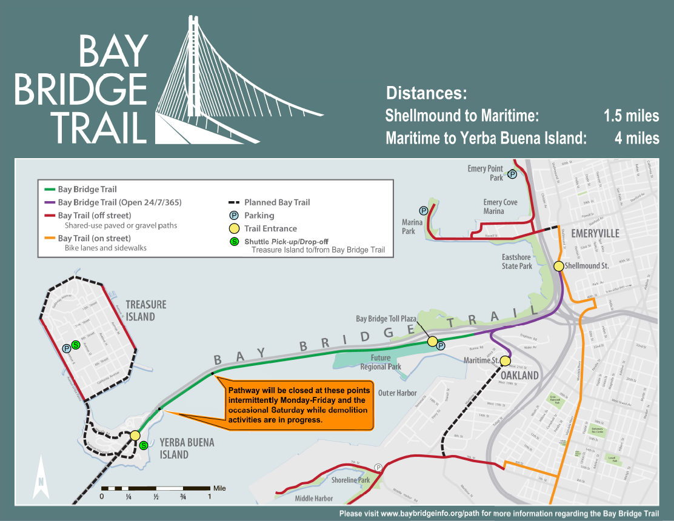

For information on shuttle service between Treasure Island and the Bay Bridge Trail, please call (415) 218-6858.



  

